**Chadel Dowridge**

**11/27/24**

**Oracle E-Business : Order Management**

1. Order Management Setup

•Define Order Management System Parameters

Order Management System Parameters are critical configure steps to set up how an application behaves in order processing, the configure steps are defining the rules of the application, the defaults of the applications, and the way the order processes within the business requirements.

2. Customer Management [Customer Creation]

•Define and Maintain Customer Accounts and Contacts

First thing i did was follow this path to define and also maintain Accounts

**Receivables > Customers > Create/Maintain Customers**

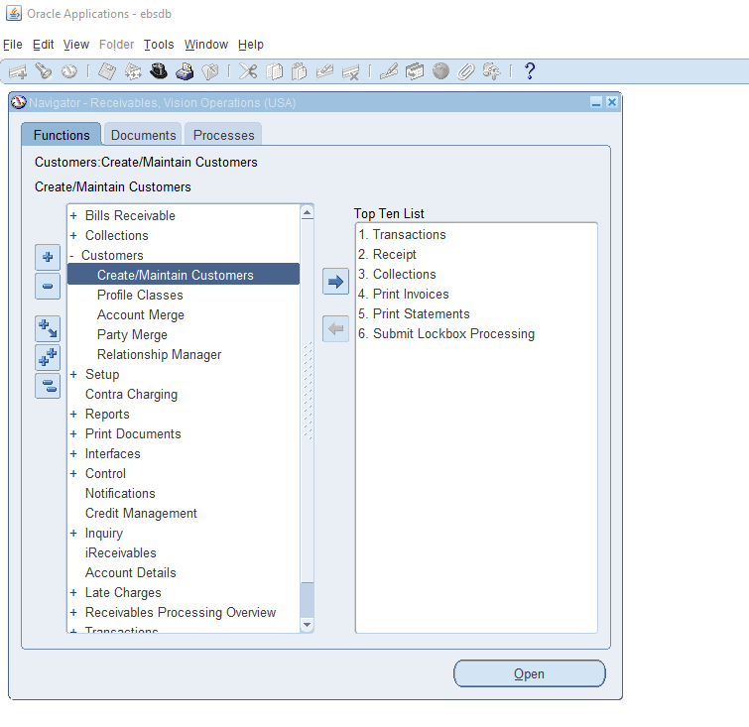

From here I followed the search parameters to search for a customer

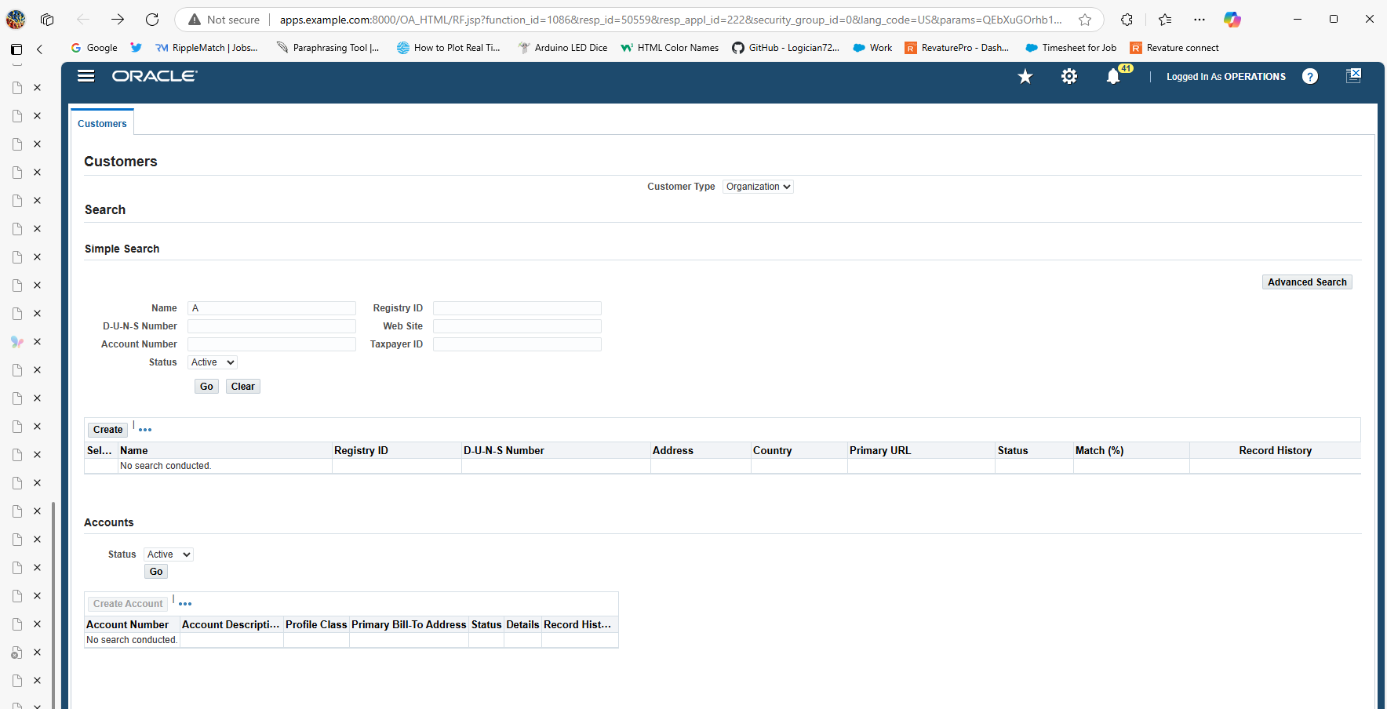

From here i searched A and got the Customer American Telephone & Telegraph (AT&T)

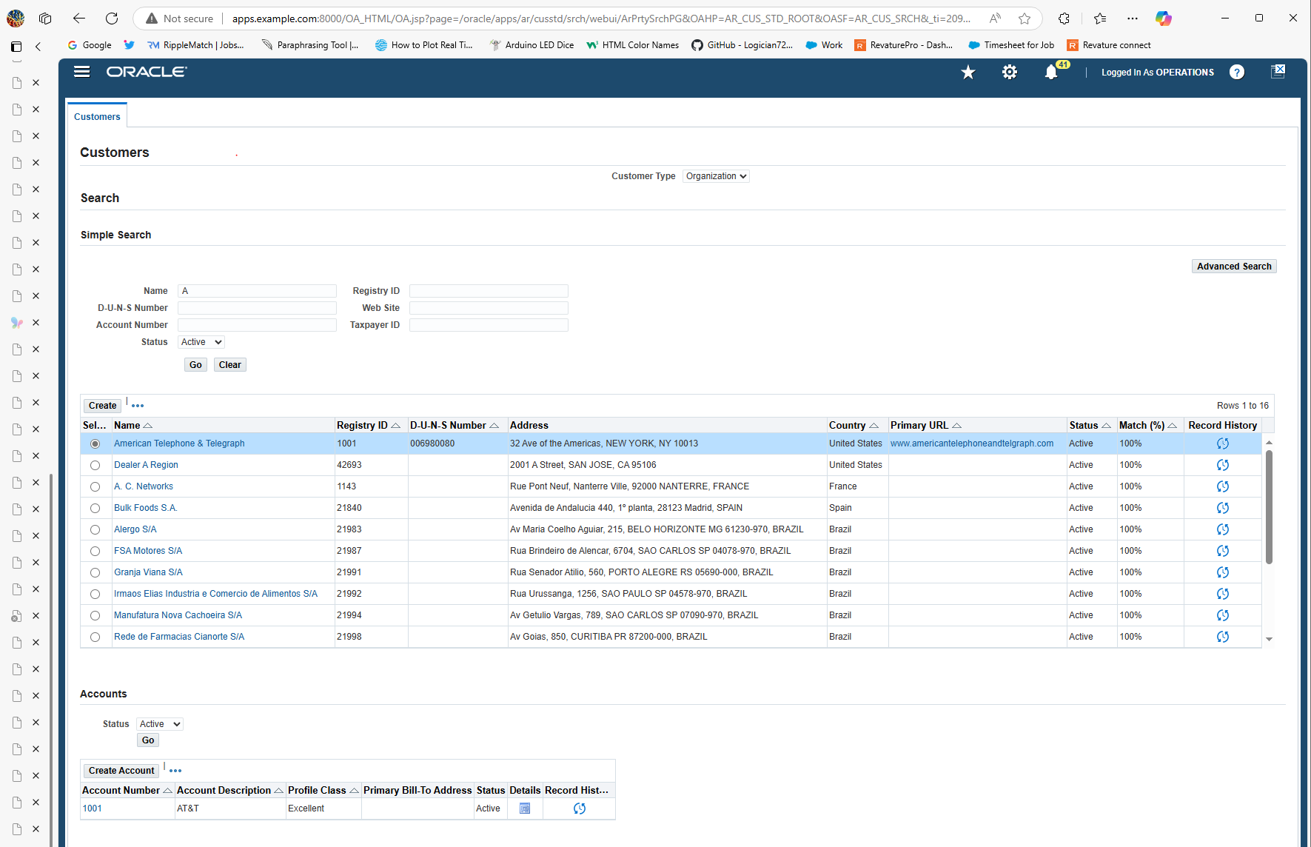

From here in order to manage the customer you have to click on the detail button thats detailed in red

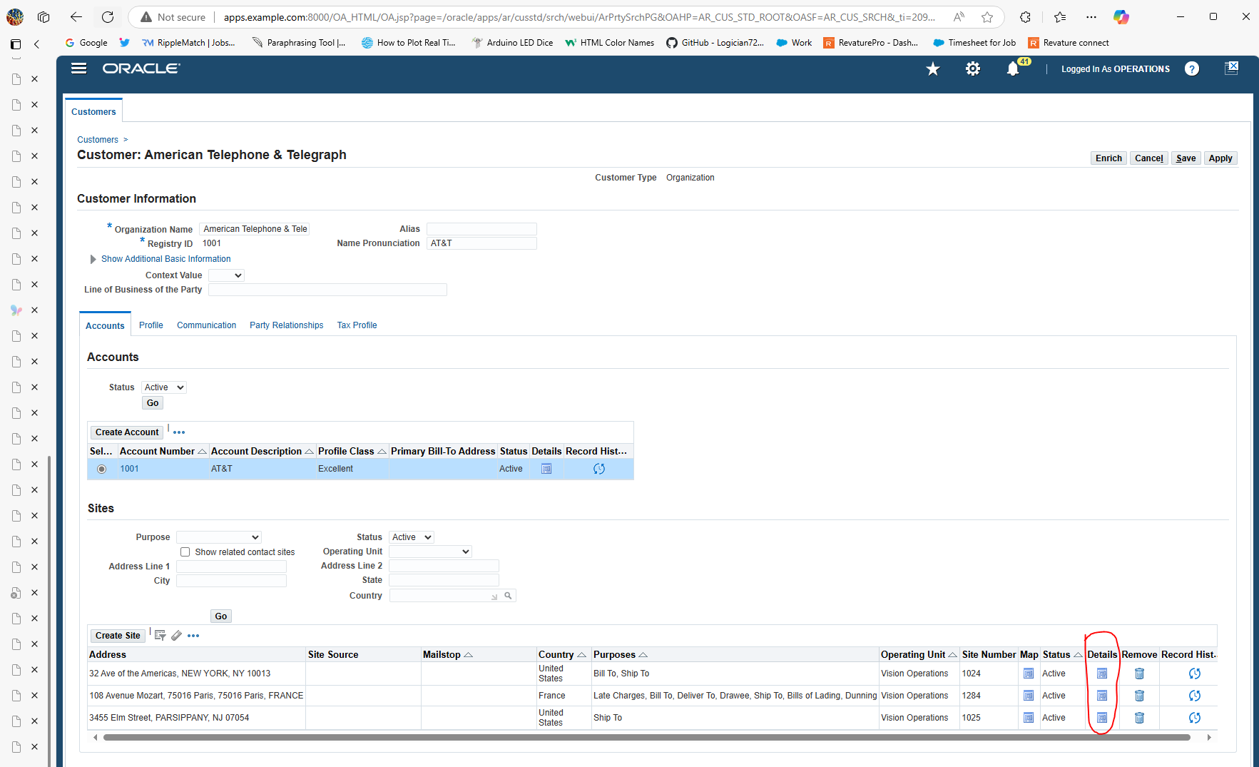

From here since this customer

•Setup Customer Shipping and Billing Information

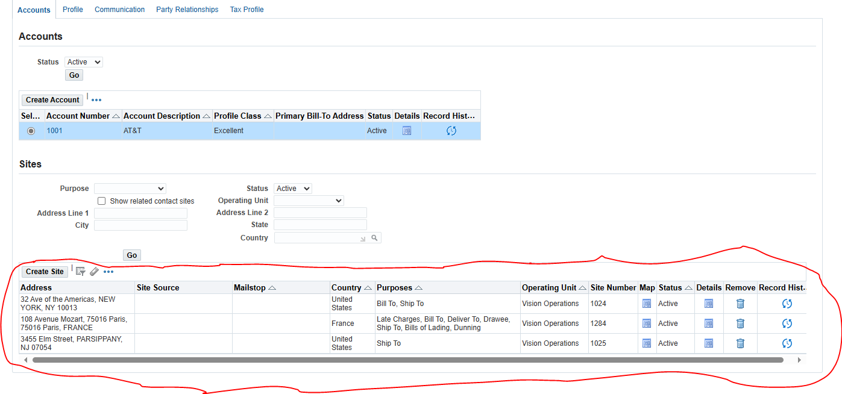

From here I clicked add create site to create a new site to set up customer shipping and billing for this new account.

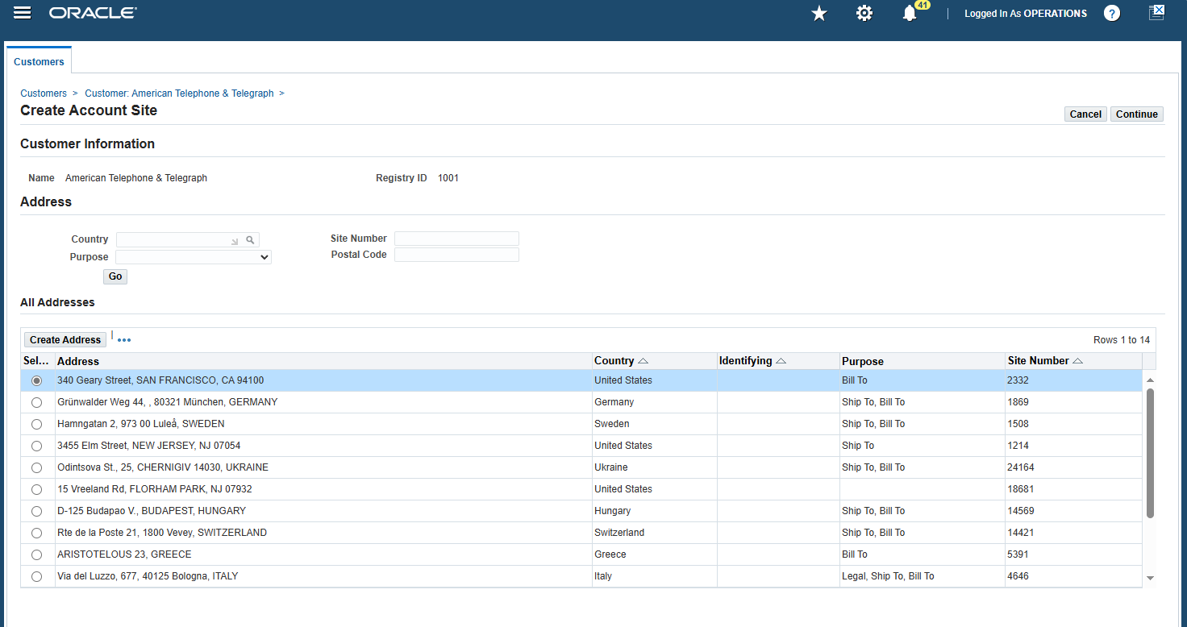

From here i clicked on create address and created a new one as follows

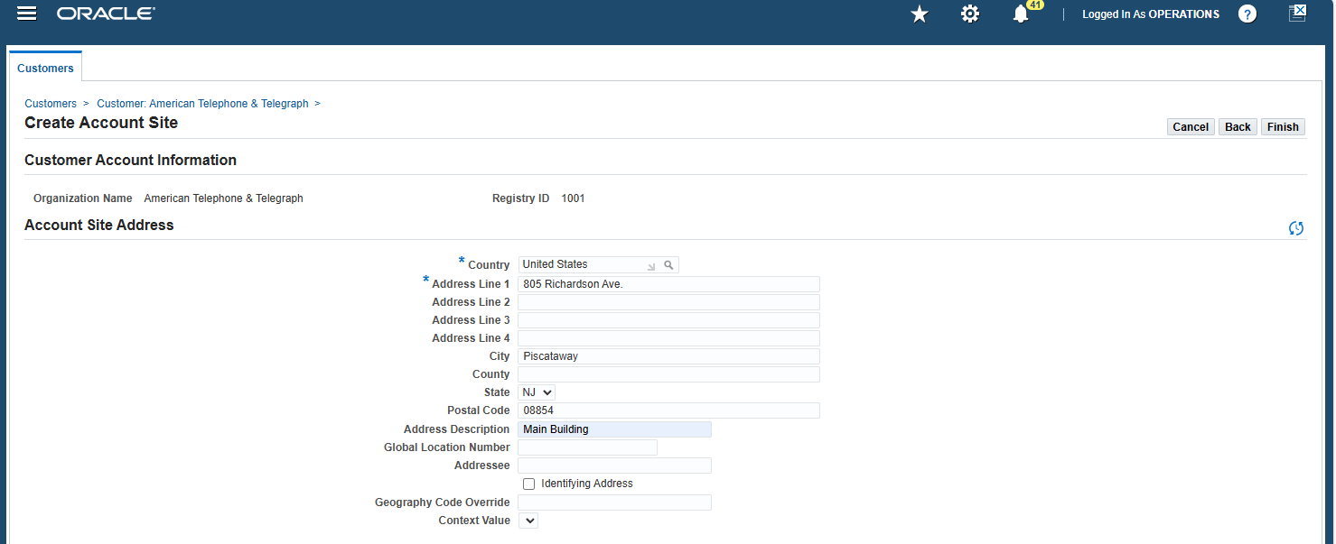

The address i put was **805 Richardson Ave. Piscataway, NJ 08854** and filled the necessary fields to create an address.

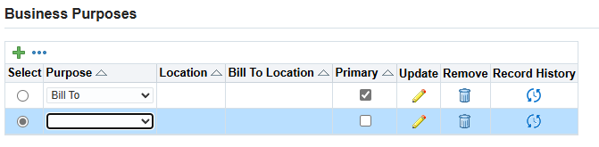

From here i clicked on the pencil to update the billing information for the customers and also a site for billing

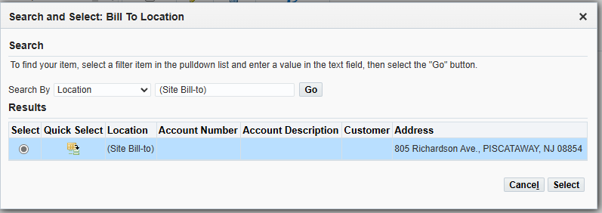

From here i clicked on the billing to the home base address i put on the created address to complete the billing portion.

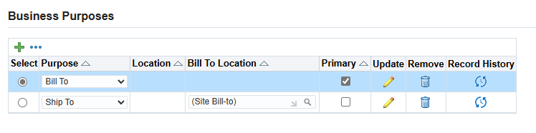

From here I made another purpose to satisfy the customer shipping, which was to have the customer shipping go to the same site. The billing was for a better shipping and billing transaction.

•Manage Customer-Specific Pricing and Discounts

First i followed this path to manage the pricing of items which is

**Order Management > Pricing > Price Lists**

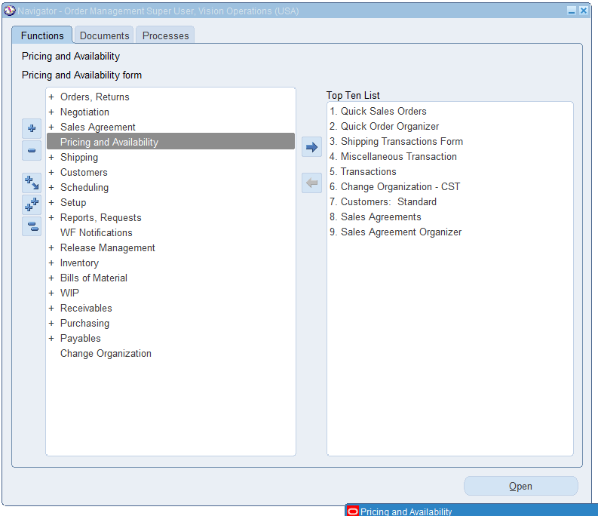

**From here i clicked on pricing and Availability**

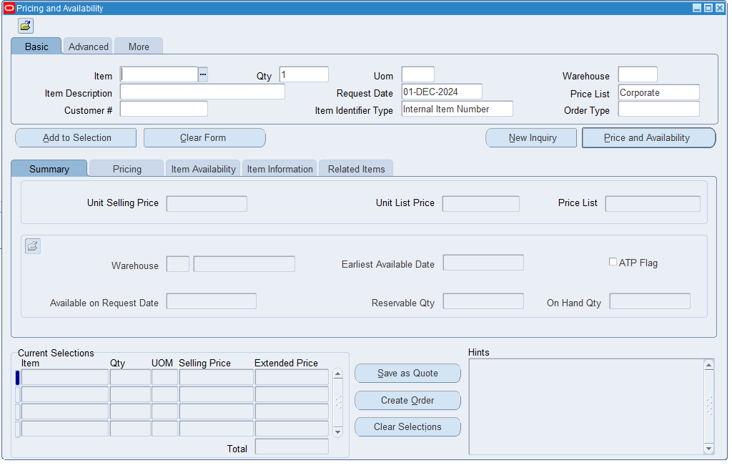

**From here I clicked on the three dots on where the item is located to bring up the values for the items that already existed.**

**From here i selected the highlighted items to inspect the price details of the item for management responsibility purposes.** 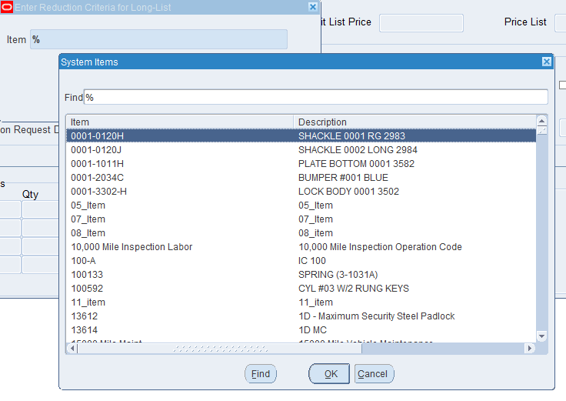

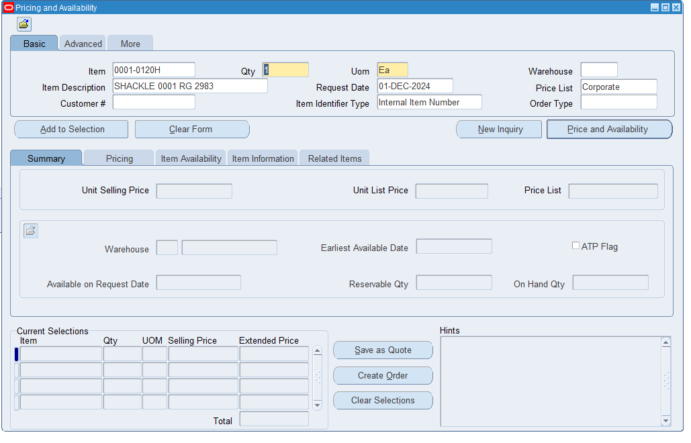

**From here i clicked on the pricing tab to check the finances on the item selected from above**

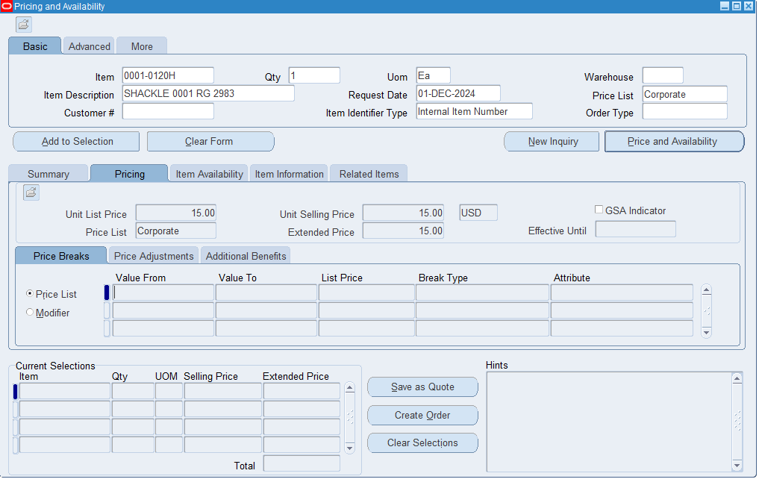

**From here I clicked and I checked the unit list price (15.00), the unit selling price (15.00), the price list (Corporate), and the extended price.**

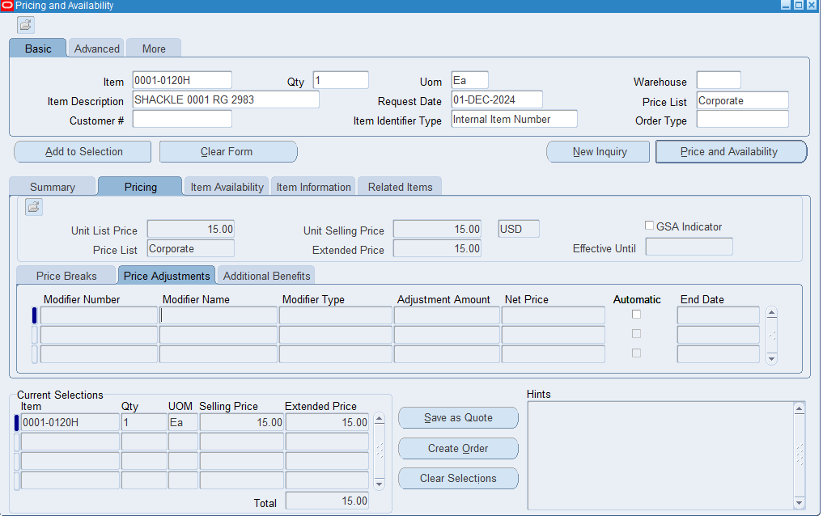

**From here I clicked on price adjustments to define discounts to try to define a discount based on type and level but was unable because the original item couldnt.**

3. Sales Order Creation and Entry

•Create Sales Orders Manually or Import from External Systems

First i did was continue on the same path as before which was **Order Management > Pricing > Price Lists**

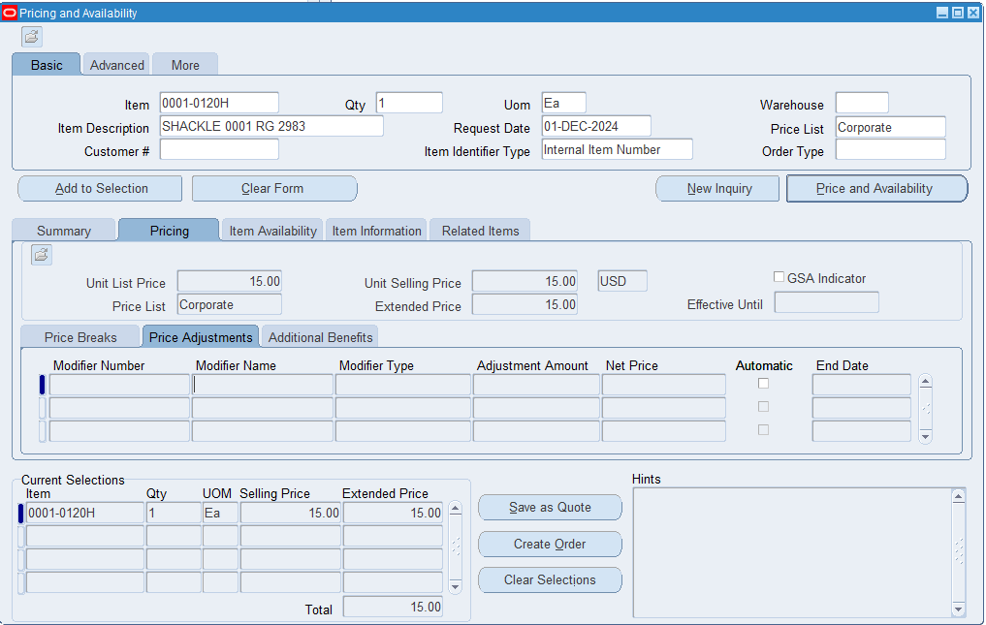

And added a order to the selections to start the process of the order from the item pricing page

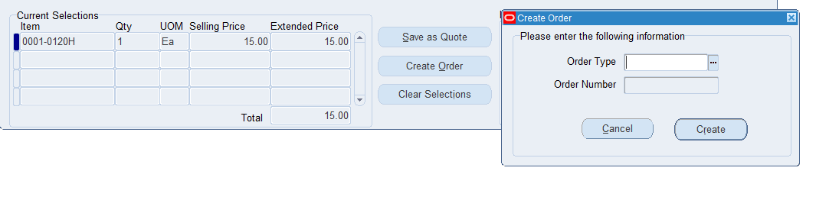

From here i clicked on create an order to create an order for the item that was selected.

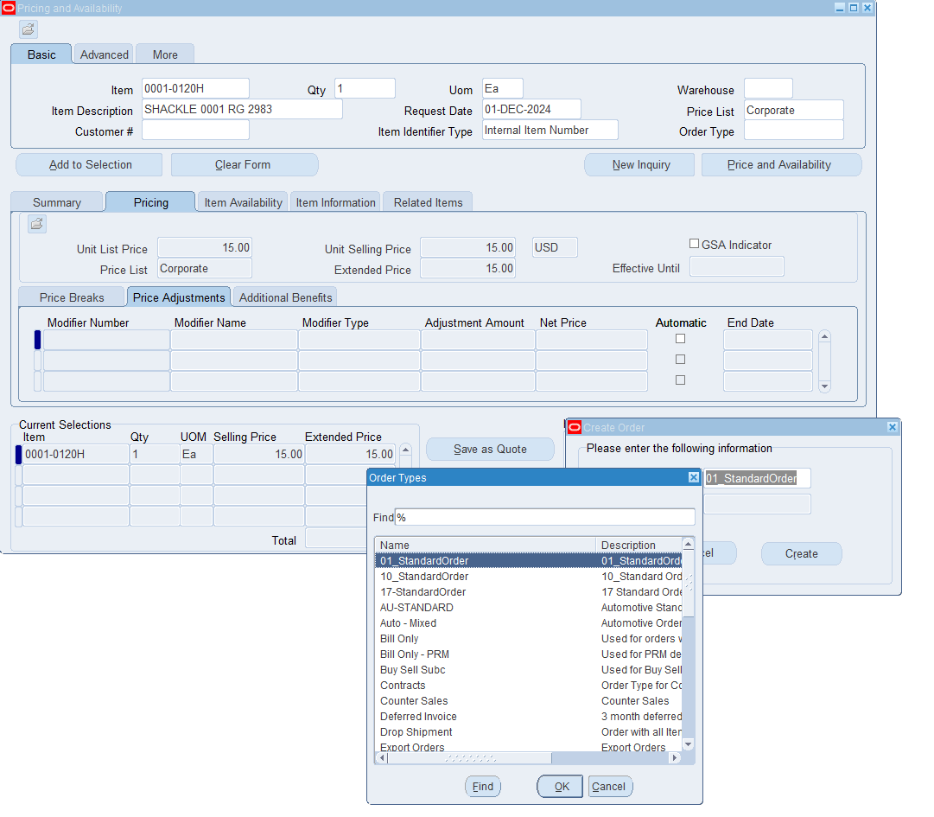

From here i selected order types and selected the order type to be standard.

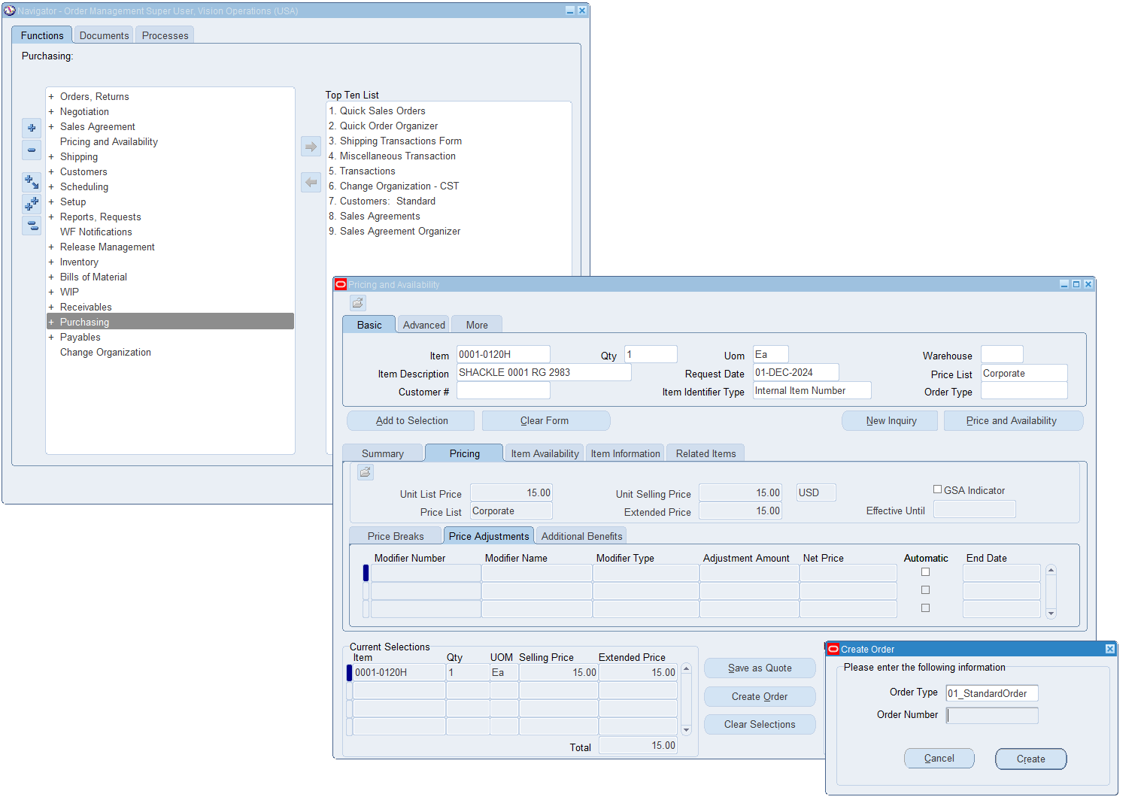

From here i clicked on create an order and it created the order for shipment using the same billing and shipping details i had on file.

Another way to do this manually is following this path **Orders > Returns > Sales Order**

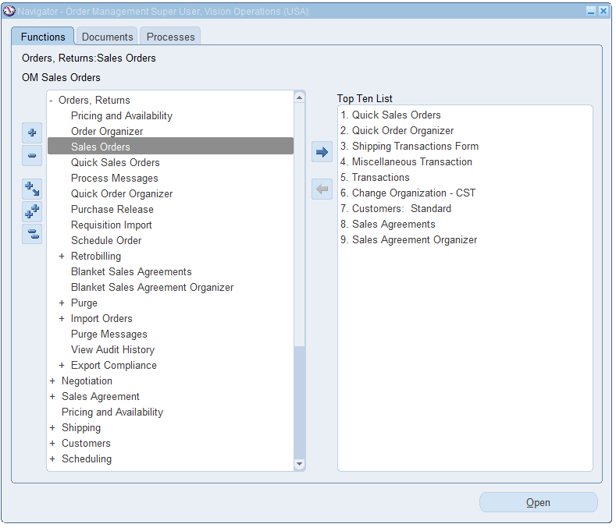

**From here I entered a customer and selected an order type to know what type of order.**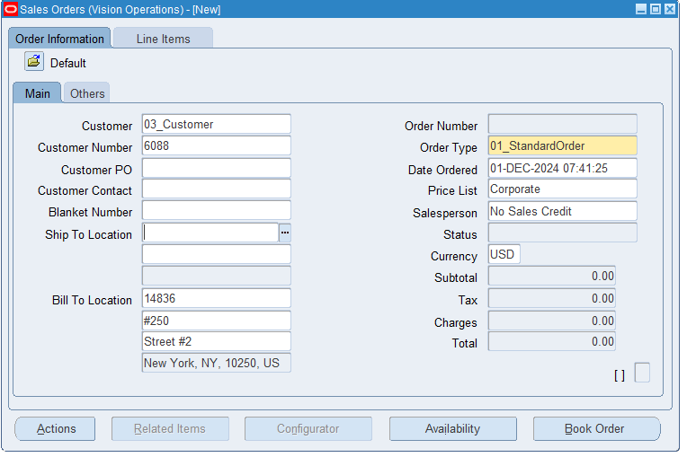

**I also then clicked on book order to start the process of processing the order.**

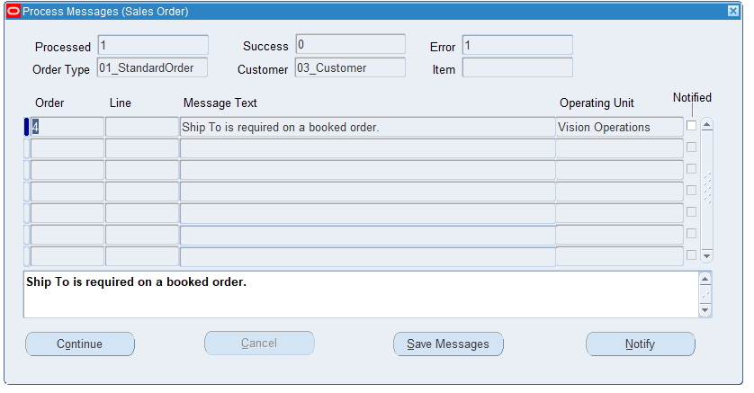

**From here i clicked on continue and it processed the order.**